

**Chandigarh University**

**University Institute of computing**



**Minor Project of Business Analytics**

Amazon sales Dashboard 2024

# 

# Submitted By- Submitted To-Dr. Javed Alam

# Name -Ankur Kumar Signature-

UID - 23MCA20493

Name-Arjeet Singh

UId-23MCA20476

Section-1/B

**Executive Summary**

* This section provides a brief but high-level summary of the project. Although it's placed at the beginning of the report, you should write it after completing the entire report.

**Summary of the Report:**

The **Amazon Sales Dashboard 2024** was developed to provide comprehensive, real-time insights into sales data across various cities and states. The project aims to help Amazon's management and business teams make data-driven decisions regarding product performance, sales regions, and marketing strategies.

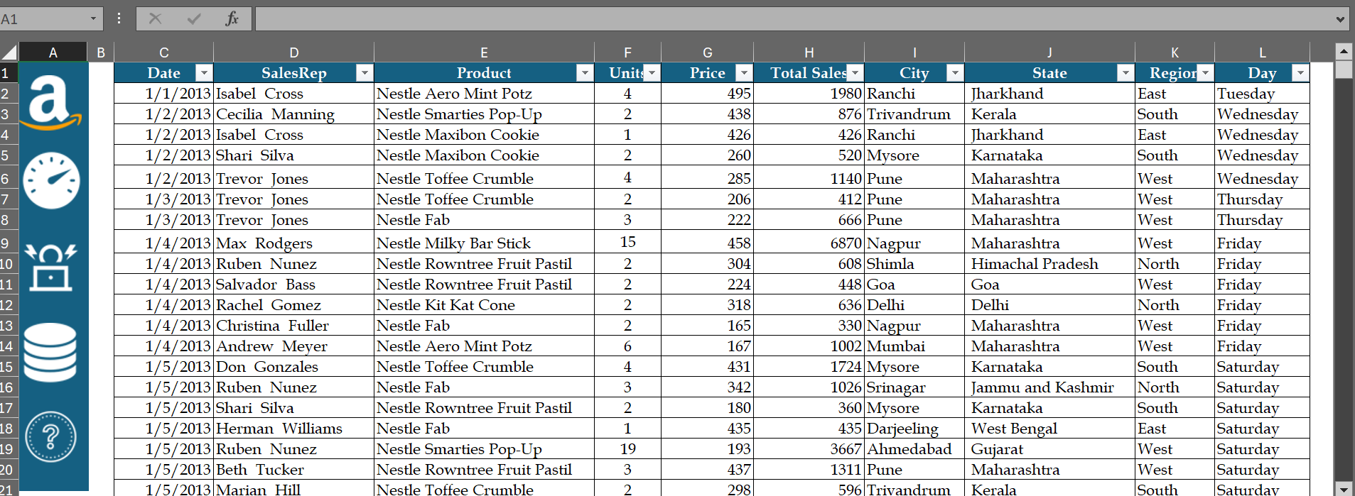

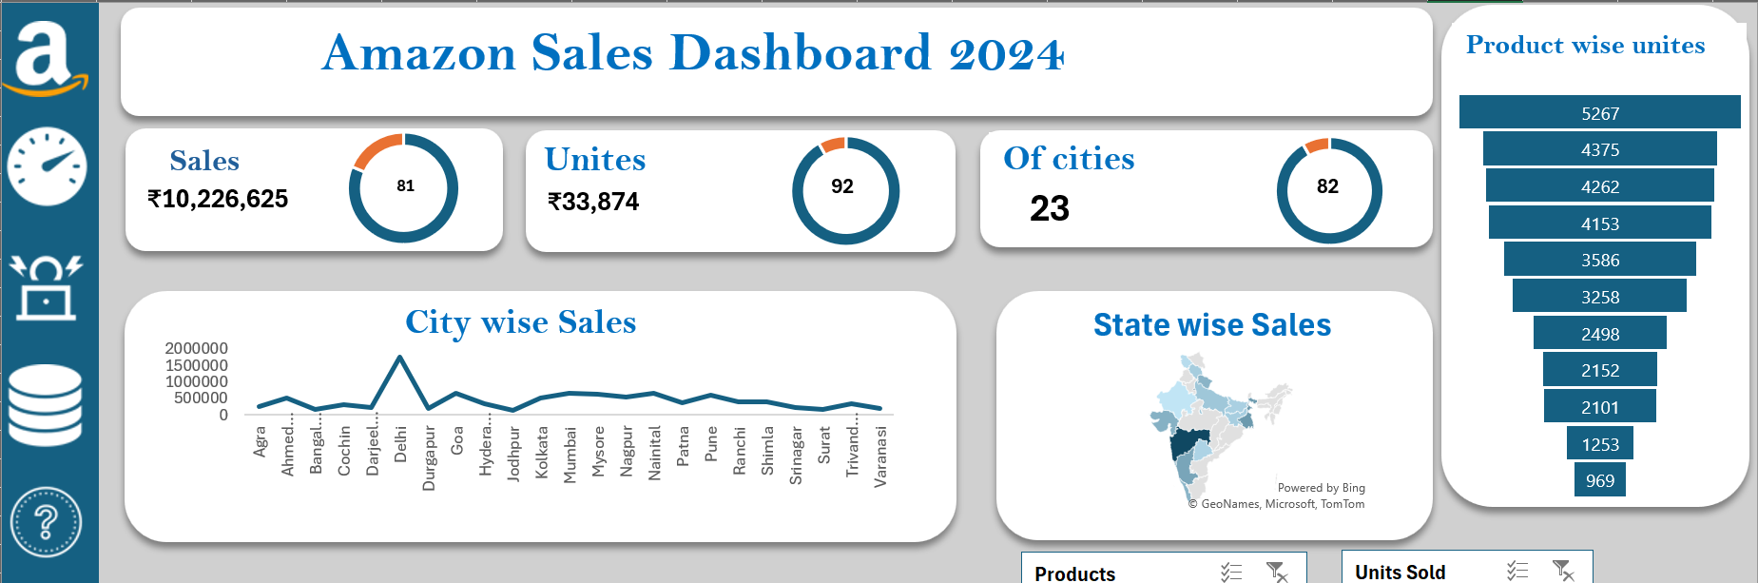

* **Key Objectives**:
  + Visualize sales data by region (city and state) to identify top-performing areas.
  + Analyze product performance to prioritize inventory and marketing efforts.
  + Provide an interactive tool that helps managers filter and explore data dynamically.

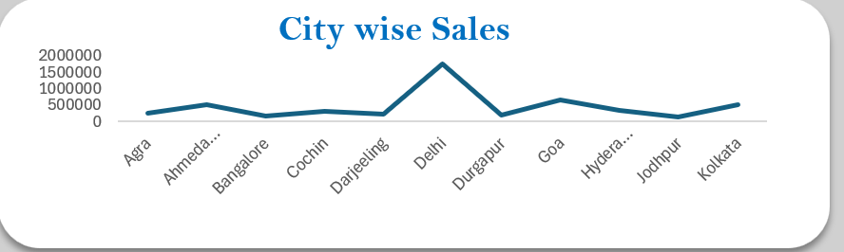

* **Business Impact**: Improved decision-making capabilities by identifying sales trends, product demands, and regional opportunities to optimize sales and marketing strategies.

**Project Introduction**

Describe the context of the project and why it was initiated.

**Business Need**:  
As Amazon expands its business across various regions, understanding sales trends by geography and product line is critical to maintaining a competitive edge. This project aims to create an interactive sales dashboard that consolidates sales data and presents it in a visually meaningful way. The ability to make informed decisions based on data is essential for managing stock, focusing marketing efforts, and optimizing regional strategies.

**4. Project Objectives**

* **Primary Goal**: To create a comprehensive dashboard that provides insights into sales performance, product units sold, and regional sales.

**Specific Objectives:**

1. **Sales Analysis**: Summarize sales by city, state, and product to identify top-performing regions and products.
2. 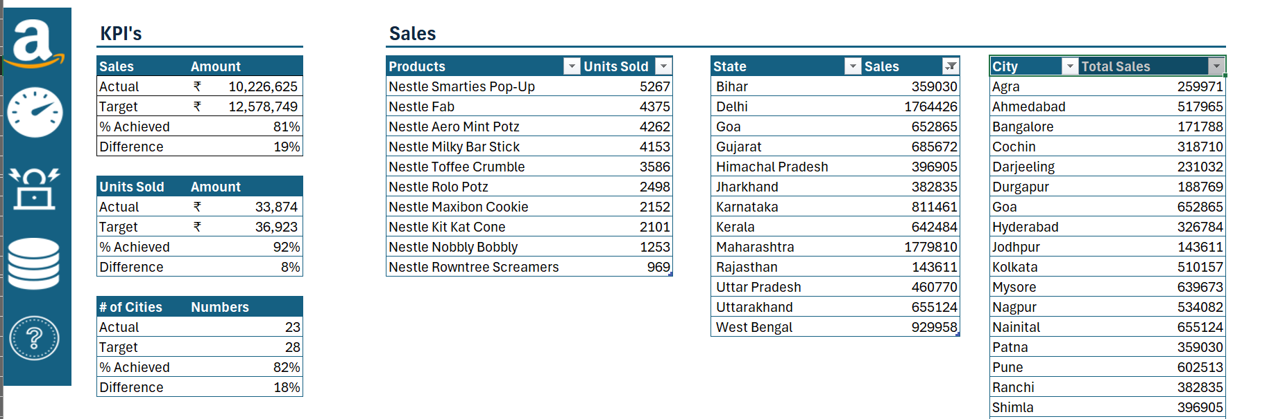**Performance Metrics**: Provide key performance indicators (KPIs) such as total sales, number of units sold, and number of cities where sales occurred.
3. **Visual Representation**: Create intuitive visualizations (charts, maps, etc.) to make the data easily understandable for business users.

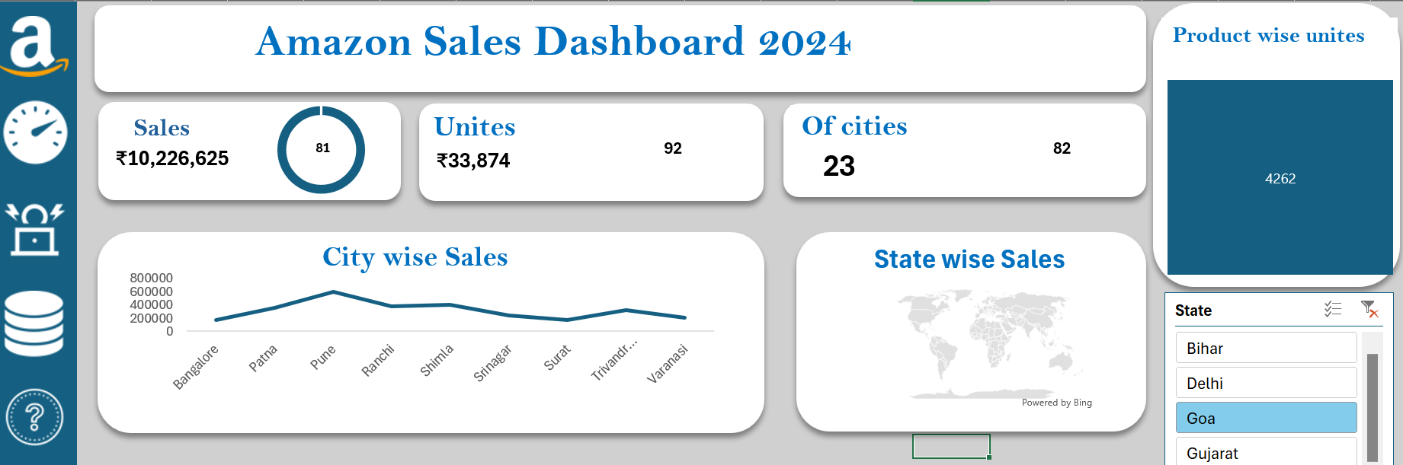

1. **Interactivity**: Allow users to filter and explore the data interactively to gain deeper insights into specific regions or products.

**5. Data Collection and Preparation**

* **Data Sources**:
  + **Sales Data**: The dataset provided contains detailed information on sales transactions, including city, state, product name, sales amount, and units sold.

**Data Cleaning:**

The data required preprocessing to ensure accuracy. This included:

1. **Handling Missing Values**: Missing data was either imputed using averages or removed if deemed irrelevant.
2. **Data Consistency**: Ensured that the city and state names were consistent throughout the dataset.
3. **Data Aggregation**: Sales data was aggregated by city, state, and product for analysis.

**Business Impact of Data Preparation:**

Clean and accurate data ensures that the dashboard provides meaningful insights. Without proper data preparation, incorrect insights could lead to flawed business decisions.

**6. Dashboard Design and Features**

**6.1 Dashboard Overview**

The dashboard is divided into several key sections, each providing unique insights:

* **Sales Metrics**: Displays total sales, units sold, and number of cities involved.
* **City-wise Sales**: A line chart that shows sales trends across different cities.
* **State-wise Sales**: A map visualizing state-level sales performance.
* **Product-wise Units Sold**: A bar chart showing which products sold the most units.

**6.2 Key Metrics**

* **Total Sales**: ₹10,226,625
* **Total Units Sold**: 33,874 units
* **Number of Cities**: 23 cities

**6.3 Interactive Features**

* **Filters and Slicers**: Users can filter the data by product, city, or state to focus on specific areas of interest.
* **Responsive Charts**: The charts update in real-time as filters are applied, allowing users to dynamically explore the data.
* 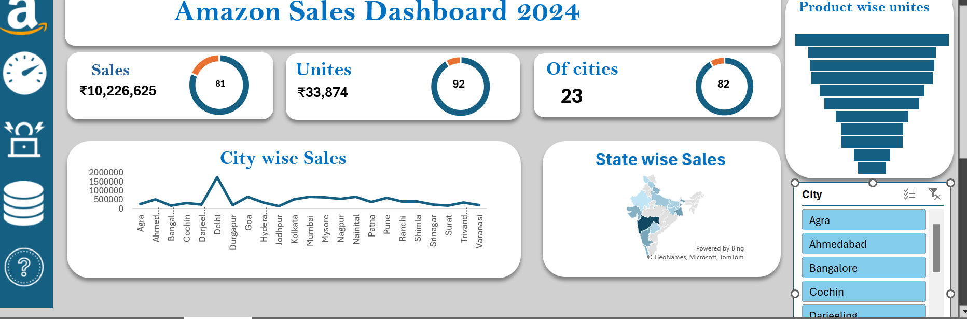

**7. Business Analysis and Insights**

This section interprets the data and explains how the dashboard can be used from a business perspective.

**7.1 Product Performance Analysis**

* **Top-Selling Products**: The bar chart clearly shows that certain products significantly outperform others in terms of units sold. This helps Amazon prioritize these products for restocking and marketing.

**7.2 Regional Sales Trends**

* **City-Level Insights**: The city-wise line chart reveals which cities are contributing the most to overall sales. For example, larger cities like Delhi and Mumbai show a spike in sales. Amazon could consider increasing marketing efforts in these areas.

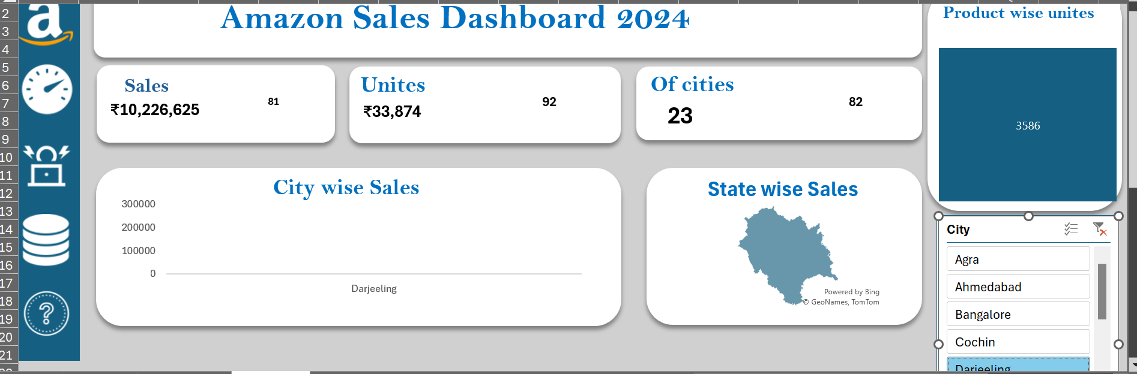

* **State-wise Sales**: The map visualization provides a high-level overview of which states are generating the most revenue. States with lower sales could be targeted for future marketing campaigns.

**7.3 Customer Preferences by Region**

By analyzing product sales in different cities, the dashboard allows Amazon to tailor its product offerings based on regional preferences. For example, certain products may sell well in urban areas, while others perform better in rural regions.

**Business Implications:**

* **Inventory Management**: With insights into top-selling products and regions, Amazon can optimize its inventory, ensuring that high-demand products are always available in the right regions.
* **Targeted Marketing**: The regional insights allow Amazon to target specific cities or states for marketing campaigns based on historical sales data, leading to more effective advertising spending.
* **Resource Allocation**: By focusing resources on high-performing areas, Amazon can maximize ROI and improve overall profitability.

**8. Technical Implementation**

**8.1 Tools and Techniques Used**

* **Excel**: Used for creating PivotTables and visualizations (charts, maps, bar graphs).
* **Power Query**: Used for data cleaning and preparation.
* **Formulas and Functions**: Used to calculate KPIs like total sales and units sold.
* **Slicers**: Added to enhance interactivity and allow users to filter data in real-time.

**9. Challenges Faced**

* **Data Inconsistency**: Handling missing or inconsistent city and state names required manual intervention and cross-verification.
* **Scalability**: Managing a large dataset in Excel while ensuring responsiveness of the dashboard posed a challenge. Performance tuning was necessary to ensure that the dashboard remained fast and interactive.
* **Visualization Limitations**: Excel’s map charts have certain limitations in terms of customization, which affected the presentation of state-wise data.

**10. Future Enhancements**

**Business Enhancements:**

* **Automating Data Updates**: By automating data refresh, the dashboard can be updated in real-time as new sales data is available.
* **Advanced Analytics**: Integration with Power BI or other advanced tools for predictive analytics (e.g., forecasting future sales trends based on historical data).
* **Customer Feedback Integration**: Incorporating customer feedback and ratings to analyze product satisfaction alongside sales.

**Deployment Outcome**

* **Successful Deployment:** The dashboard is fully functional, with users able to access and interact with it without issues.
* **Improved Insights:** Management can now make data-driven decisions more efficiently.
* **Secure Access:** Role-based access ensures data privacy and security, with only relevant team members able to view or modify information.

**Conclusion**

The **Amazon Sales Dashboard** is a powerful tool that empowers decision-makers by providing valuable insights into sales trends, regional performance, and product demand. By utilizing this data, Amazon can:

* Improve inventory management.
* Optimize regional marketing strategies.
* Make data-driven decisions to boost sales and profitability.

The dashboard not only simplifies the analysis process but also makes it accessible to non-technical business users, enhancing overall business efficiency and decision-making.

1, 2023 to June 30, 2024)

